1.0 Scope |  |  |  | 2.0 Resource Required
1.1 Purpose: Calculating Glass pull tons by sample weight  1.2 Area of Application: All annealed lines  1.3 Responsibility: Shift Packing Officer  1.4 Accountability: Section head & Production head |  |  |  | 2.1 Man: Shift Packing Officer  2.2 Machine: Weight scale, glass cutter & mesuring tape.  2.3 Material: Glass sample.
3.0 Terms and Definition |  |  |  | 4.0 Key Performance Requirements
3.1 TPD: Tons per day |  |  |  | 4.1 Quality: Precisely calculation of glass pull based on the glass drawn from the rolling machine.  - EHS: No cut injury
5.0 Frequency |  |  |  | 6.0 Competency Enhancement
5.1 Once in shift & whenever requirement. |  |  |  | 6.1 Training on Pull calculation by glass weight activity to be given to all shift officers.  6.2 Visual posters are to be used for communication.
7.0 Procedure
7.1 Sequence of Operation

7.1.1 Ask cutting team to call the glass sample from line.

*Ensure the stability of line before calling the glass
Sample.
The sample will be given by cutting operator from the Grenzebach screen.

7.1.2 Request the Glass sample from Grenzebach HMI with trim Intact (Shown in image). |  |  |  |  | 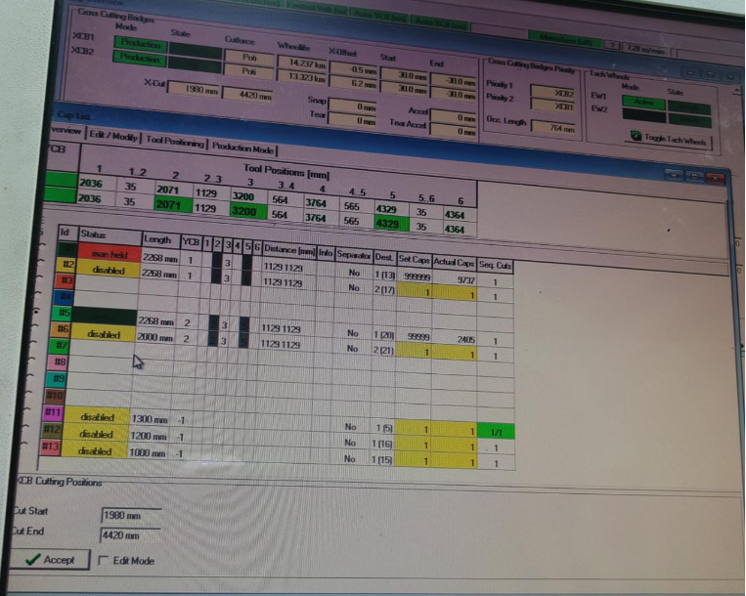  Grenzebach screen Bentler M2
7.1.3 Verify the dimensions of the sample (length, width) (as shown in image). |  |  |  |  | 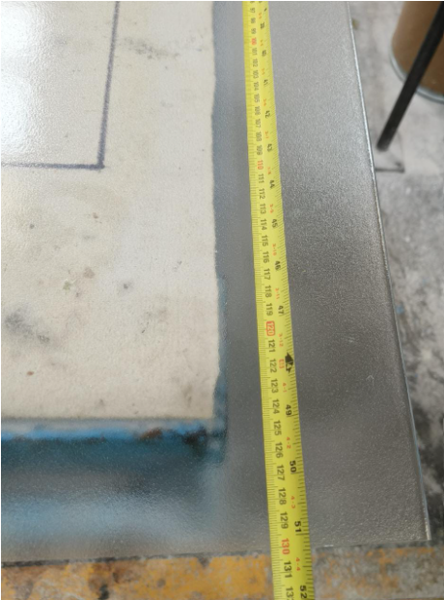
7.1.4 Move the glass to cutting table. (as shown in image) |  |  |  |  | 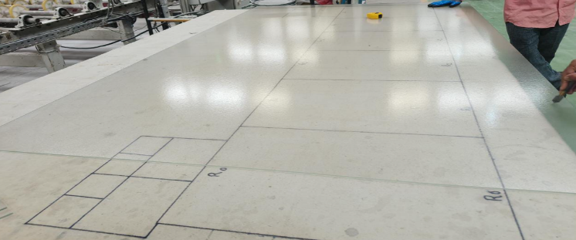
7.1.5 Cut the sample into 6 equal parts + 2 trims (left & right) (as shown in image) |  |  |  |  | 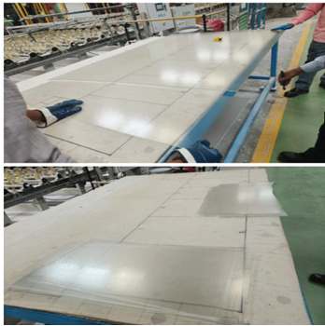  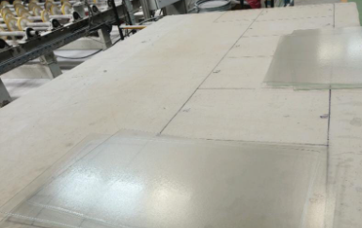
7.1.6 Press the “Zero” or “Tare” button to calibrate the weighing scale and set the baseline reading to zero before performing weight measurement.
7.1.7 Put all the pieces of the glass on the weighing scale platform. (as shown in Figure-05) |  |  |  |  | 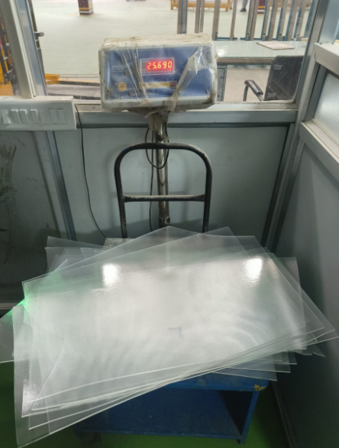
7.1.8 Note the weight of the sample which is shown on the display.
7.1.9 Calculate the Glass pull by following the formula below:
Glass pull (in tons/day) = (W * V * 1.44) / L
Where:
W: Weight of the sample in Kg.
V: Lehr speed in m/min.
L: Length of the sample in meter.

7.2 Special Process Requirements
7.3 Prevention & Detection Controls
7.3.1 Identify any significant variation in the pull if needed and share the information with Hotend Shift in charge.

7.4 Controls Related to EHS
7.4.1 PPE MATRIX
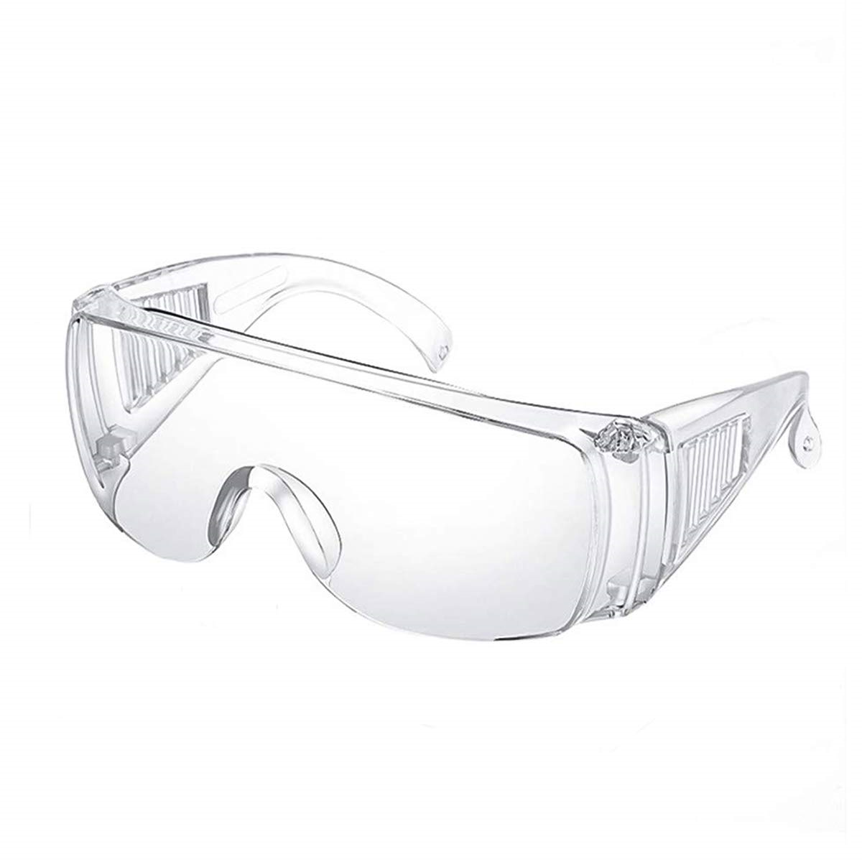 | 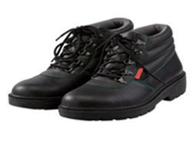 |  | 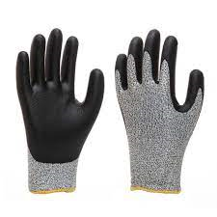 |  |  |  | 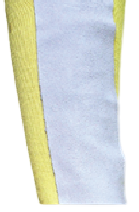
Goggles | Safety shoes |  | Hand Gloves |  |  |  | Arm Guard
7.4.2 After completion of activity, dispose of the glass sample in the cullet bin.
8.0 EHS Compliance Obligations
8.1 Not applicable

9.0 Possible deviation & Impacts |  |  |  |  |  | 10. Proposed actions
9.1 Improper sample size/weigh may lead the incorrect calculation  9.2 Improper use of formula may lead to wrong calculation & feedback |  |  |  |  |  | 10.1 Always “zero” set to weight machine prior to weight measurement & measurement of the sample size is necessary  10.2 Formula should be exact as mentioned in step 7.1.9
11. Reference documented information
11.1 Daily pull data Annexure-1

12. Revision History
Revision No. | Date | Description of changes
00 | 12.02.2020 | Initial release.
01 | 01.07.2023 | Picture & safety requirement added
02 | 08.07.2025 | Format standardized, revision history added, step correction done.

